## Name :- Yash Gupta

## UID :- 20BCS5009

## Sec :- 704-A

## Subject Code :- 20CSP-259

## Subject :- Programming in Python

**Experiment 1.1**

1. **Write a  program c to enter two numbers and perform all arithmetic operations.**

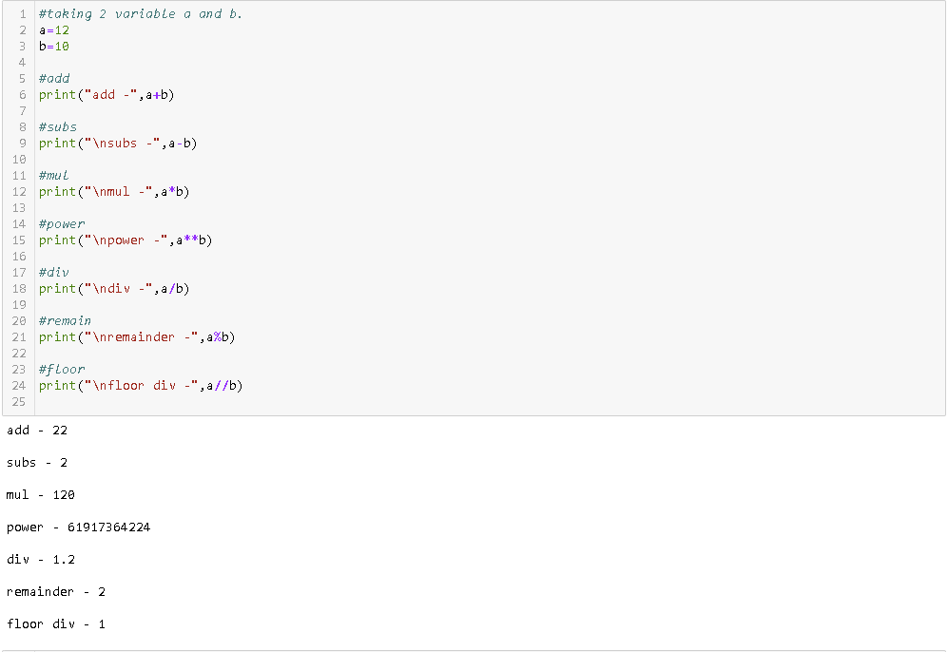

1. **Write a  program to enter marks of five subjects and calculate total, average and percentage.**

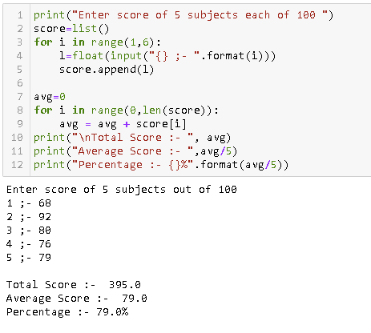

1. **Write a  program to enter length in centimeter and convert it into meter and kilometer, and also convert the same into Equivalents.**

